Doc No: BCIM/HYD/MS/ LH10/02
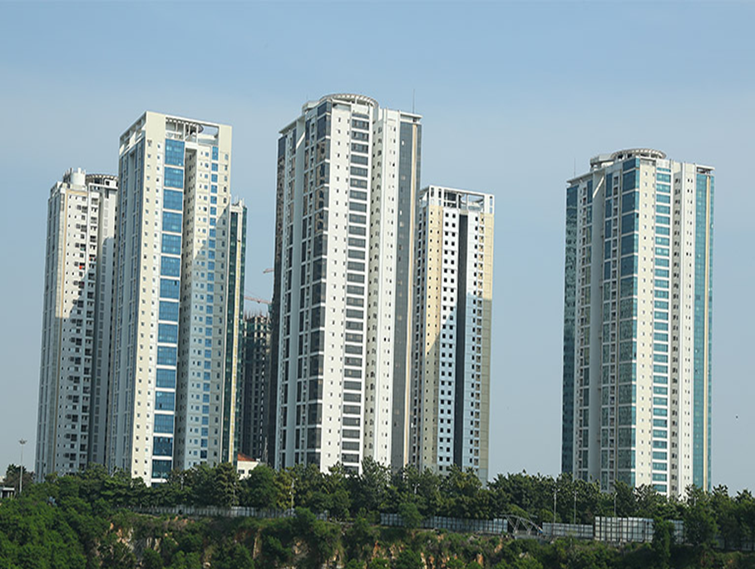
Project Name |  | LANCO HILLS RESIDENTIAL PROJECT- LH 10 ,HYDERABAD
Client |  | LANCO HILLS TECHNOLOGY PARK PRIVATE LIMITED
PMC |  | SAVILLS PROPERTY SERVICES (INDIA) PRIVATE LIMITED
Main Contractor |  | BCIM ENGINEERING PVT LIMITED
REVISION HISTORY
REV.NO | DATE |  | DETAILS OF REVISION
R0 | 13.05.2026 |  | Initial Issue for review and approval
PREPARED BY  BCIM |  |  | REVIEWED BY  BCIM | REVIEWED & APPROVED BY  PMC/Client

- Objective

The Purpose of this procedure is to follow to carry out the Internal Plastering works in order to achieve compliance with the contract specifications.

IS: 1542 Specifications for plaster sand.
- Materials
- Cement
- M Sand
- GI Plaster Mesh
- Nails

- Tools & Tackles
- Gauging Trowel
- Spirit level
- Straight Edge
- Metal Float
- Wooden Float
- Plumb Bob
- Sponge
- Ghamela

- Mortars
  - Mortars shall be specified by proportion only and not by strength. Volumetric mixing shall be based on dry volumes of each ingredient.
  - Measurement shall correspond to volume of one cement bag i.e. 0.035 cum. Boxes shall be of size 40 X 35 X 25 cm. These shall be marked as mortar mixing boxes by red paint and shall be used throughout the contract. Hand mixing or mechanical mixing proportions shall be done with the use of these boxes.
  - Cement mortar shall be prepared by mixing cement and sand in specified proportions
  - The mortar mixed shall be consumed within 30 minutes of its mixing.
  - The water absorption shall not be more than 10 percent by mass.

6.Workmanship
- Preparation of mortar mix
- The material used in preparation of plastering mixes shall be measured by volume using gauge-boxes or by weight
- Cement and sand shall be mixed dry in required proportion to obtain a uniform colour and water shall then be added to get the required consistency for the plaster
7. Method Of Internal Cement Sand Plaster
- Surfaces to be plastered must be clean and free from dust, loose material, oil, grease, mortar droppings, sticking of foreign matter,
- It is very important to ensure that there should not be any chance of the plaster getting de-bonded due to presence of materials harmful for bonding.
- Walls should be sufficiently damp prior to plastering. Water from plastering mortar must not be absorbed by masonry under any condition.
- Thickness of one coat should not be more than 15mm and less than 8 mm for single coat finished plaster
- Internal plaster should be one coat with CM1:5 of 12mm-15mm thick not more than for all the areas or as specified in BOQ.
- For all RCC surfaces plaster should be 6mm thick or as specified in boq
- Curing shall be done for a period of 7 days
- Required concealing services must be completed and tested. No further cutting of masonry must be ensured.
- Plaster dabs are checked for plumb and level by the Engineer representative
- The gap if any between the column or beam bottom and the block masonry should be well packed with masonry mortar.
- Mesh is cut to the required size and kept ready for fixing.
- The mesh should be 150mm in width so that the mesh can cover 75mm on either side of the junction.
- Hacking of the concrete surface should be completed.
- The gap if any between the column or beam bottom and the block masonry should be well packed with masonry mortar.
- Mesh is cut to the required size and kept ready for fixing.
- The GI mesh is then fixed rigidly over the junction using G I nails.
- Once the mesh is fixed over the junction it is plastered/packed with rich cement mortar to a suitable thickness such that a minimum of 6 to 8mm plastering thickness.
- The surface is made rough when the mortar is wet, so that there is a good bonding surface internal plastering work.
- Finally curing should be ensured at least 2 to 3 days before starting regular plastering
- Fixing of plaster Mesh of Arpitha make of 150mm width at the Column corners, wall corners, with Galvanized nails etc.
- The plaster shall be finished just with wooden float to give the best smooth surface
Instruments:

- Hammers
- Mixing tray
- Plumb bob
- Measurement Tape
- Try square
- Sprit level

ATTACHMENT

- Check list for Plastering

